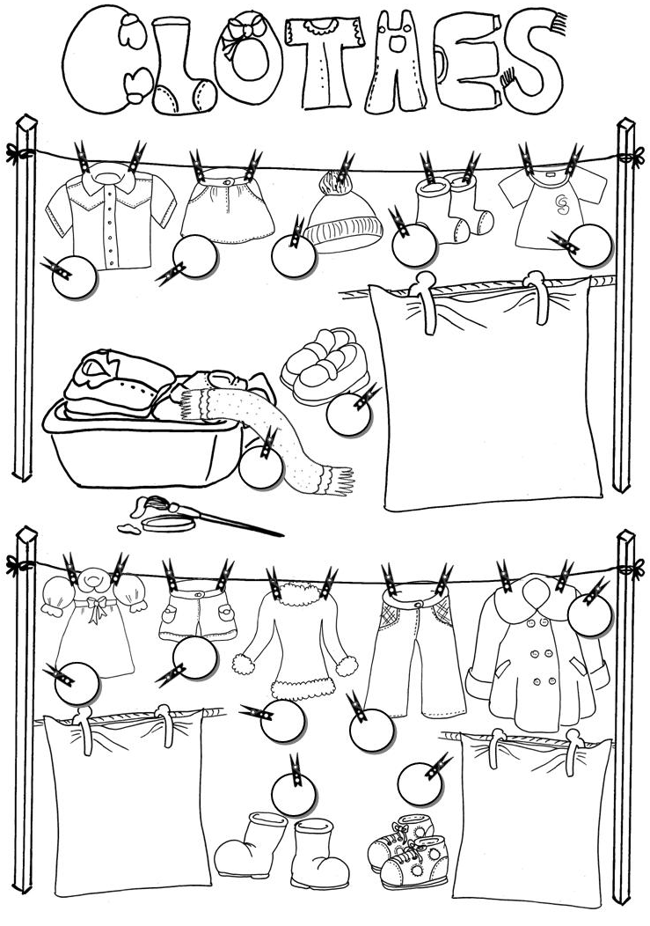
READ & MATCH
COLOUR
The dress is pink.
The socks are white.
The shorts are brown.
The trousers are blue.
The coat is purple.
The boots are black.
The shirt is green.

The sweater is red.
The scarf is grey.
The shoes are red.
The T-shirt is green.
The hat is yellow.
The trainers are blue.
The skirt is purple.
1 SCARF
2 SKIRT
3 T-SHIRT
4 SHIRT
5 HAT
6 SHOES
7 SOCKS
8 SHORTS
9 DRESS
10 TRAINERS
11 COAT
12 SWEATER
13 TROUSERS
14 BOOTS

